3.8.4 Database Performance Evaluation
ACLRS MySQL Database Testing
Tester | Harsh Patel
Test Date | 27/09/2026
Database Environment | MariaDB / MySQL on XAMPP
Evaluation Tool | phpMyAdmin Status and Monitor
Test Platform | Microsoft Windows and Google Chrome
Evaluation Objective
The purpose of this evaluation was to check whether the ACLRS database remained active, responsive and stable while the website was being used. The test reviewed server traffic, database connections, active processes, query activity and live monitoring information in phpMyAdmin.
Evaluation Method
The ACLRS website was opened locally through XAMPP and different portal functions were used to create normal database activity. The phpMyAdmin Status pages were then used to review server traffic, active processes, query statistics and live monitor graphs. This evaluation represents the local development environment and does not represent a full production load test.
Evaluation Summary
Test Area | Evidence Checked | Observation | Result
Server Status | Traffic, connections and uptime | The local server was running and processing network traffic without an aborted connection being displayed. | PASS
Processes | Current server processes | Normal system processes and local phpMyAdmin connections were visible. No long-running blocked process was shown. | PASS
Query Statistics | SQL statement counts and query chart | SELECT and supporting SQL statements were processed successfully. The query statistics displayed normal website and administration activity. | PASS
Monitor | Questions, connections, processes and traffic graphs | The graphs remained stable during the observed local test period and no sudden abnormal increase was visible. | PASS

Database Performance Evidence
The screenshots below are arranged in the same order as the performance checks completed in phpMyAdmin.
1 Server Status and Network Traffic
The server status page confirmed that the database server was active and processing traffic. The screenshot shows received and sent data, total connections, maximum concurrent connections and no displayed aborted connection during the recorded period.
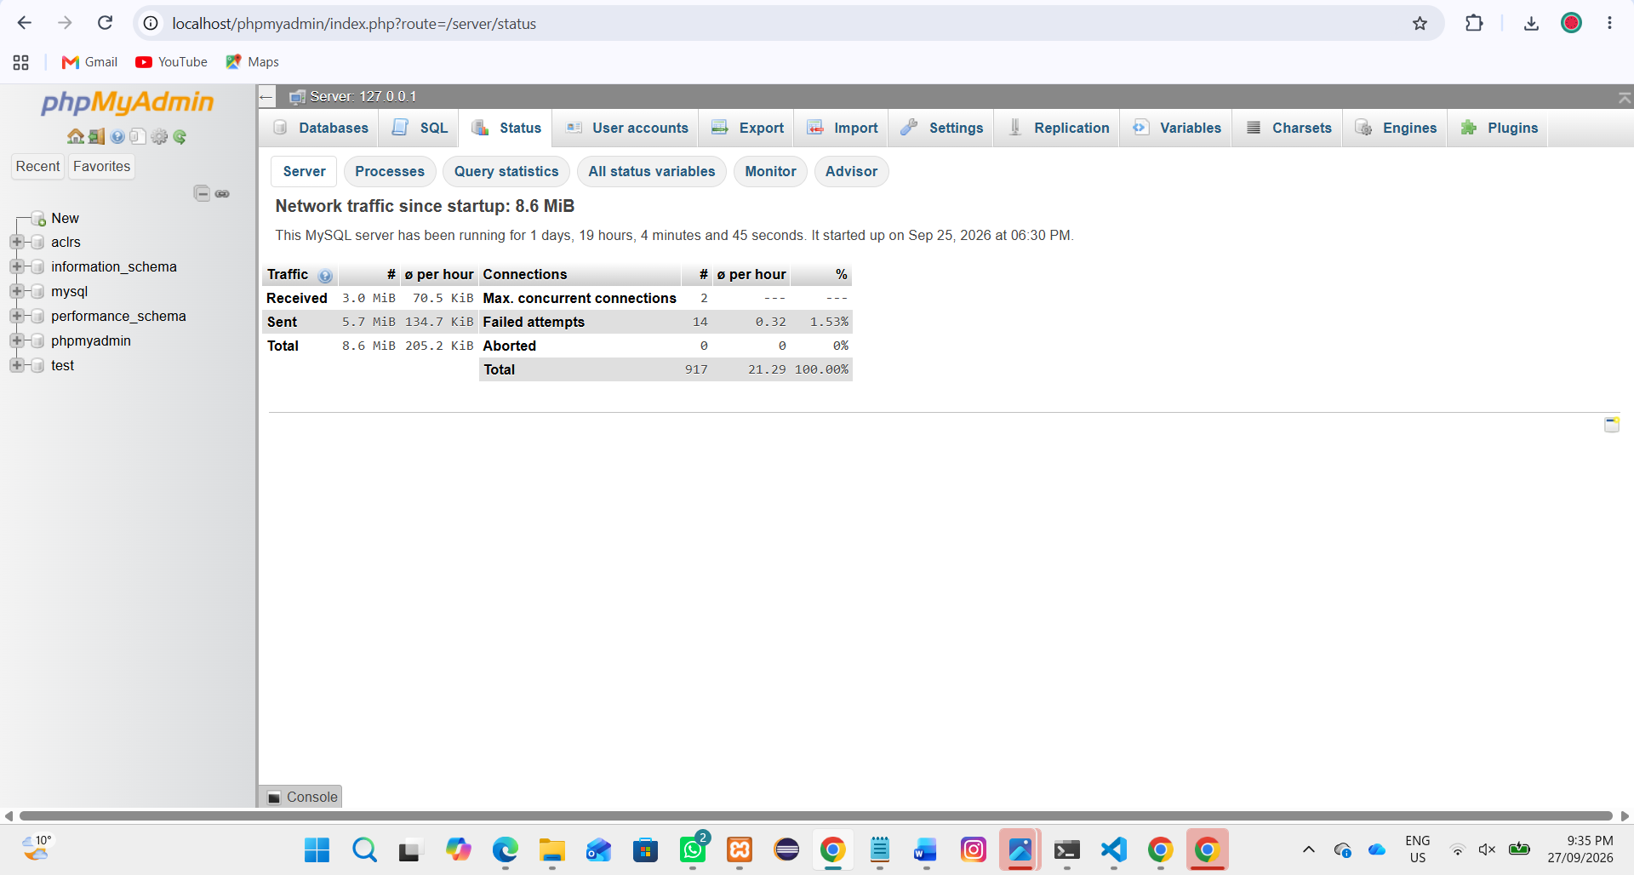
Figure 3.8.4.1 - phpMyAdmin server status and network traffic

2 Active Database Processes
The process list showed the current MariaDB system processes and the active local phpMyAdmin query. No process was shown as blocked for an unusually long time. This indicates that the database was responding normally during the local test.
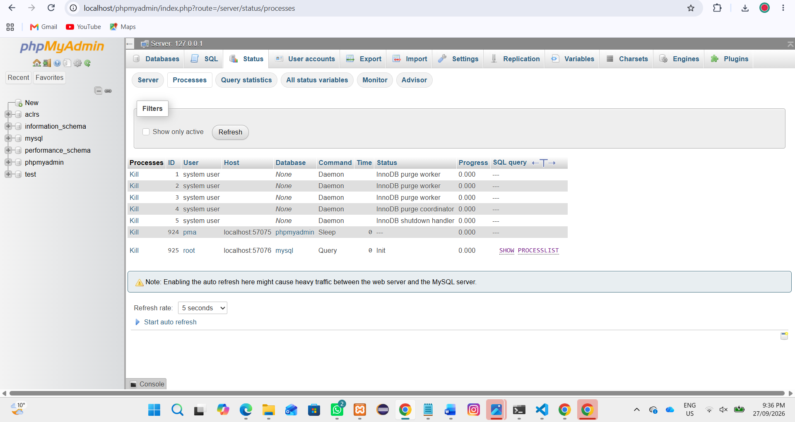
Figure 3.8.4.2 - Active MariaDB processes and local database connections

3 Query Statistics
The query statistics page showed that the server had processed different SQL statement types. SELECT was the most common operation, which is expected because the ACLRS portals frequently retrieve patients, appointments, requests, referrals, reports and notifications.
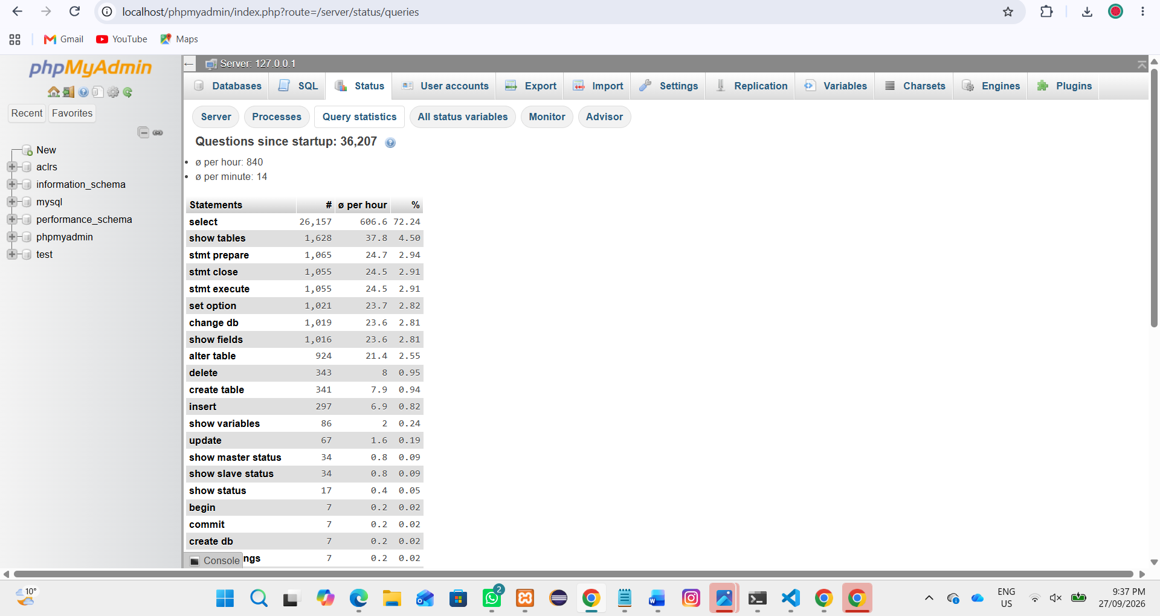
Figure 3.8.4.3 - Query statistics and SQL statement counts

4 Query Distribution Chart
The query chart provides a visual comparison of the SQL operations processed by the server. The chart confirms that data-retrieval queries formed the largest part of the recorded activity, while other administration and update operations used smaller proportions.
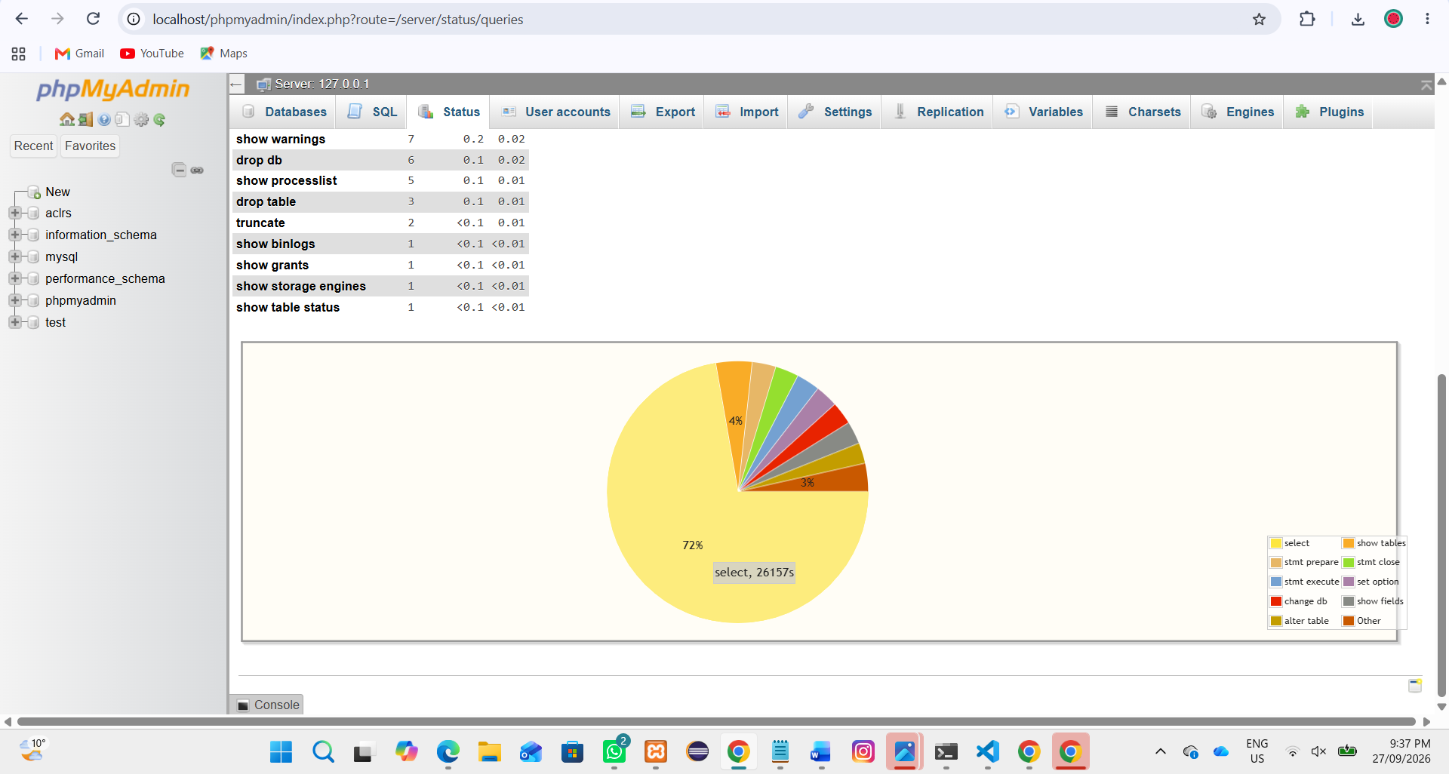
Figure 3.8.4.4 - Visual distribution of database query types

5 Live Database Monitor
The live monitor displayed questions, connections, active processes, traffic and system resource information. The recorded graphs remained steady during the observation period and did not show a sudden increase or database failure.
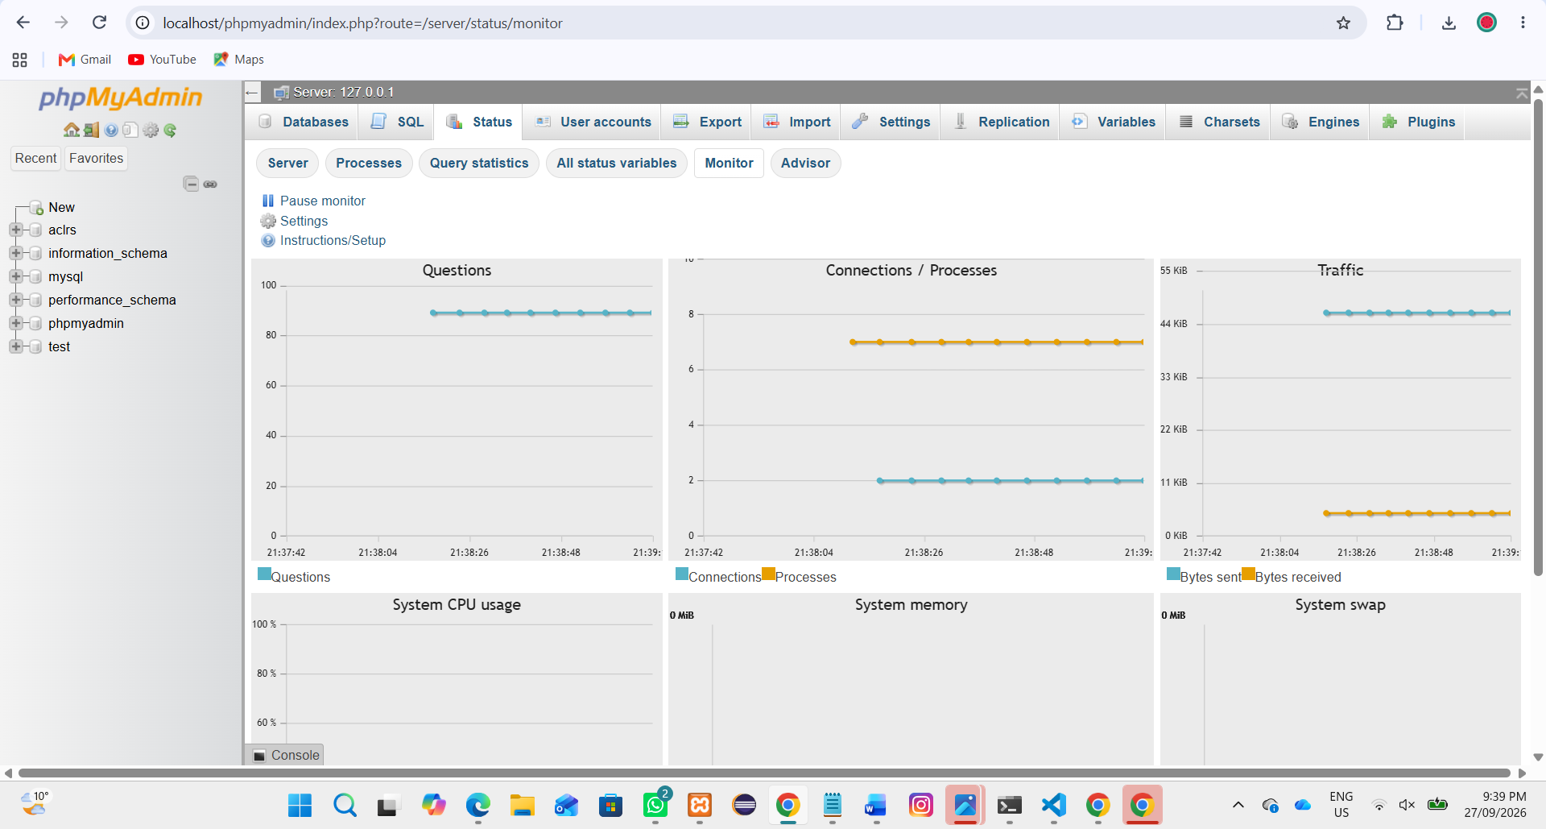
Figure 3.8.4.5 - Live database questions, connections and traffic monitoring

6 System Resource Monitor
The second monitor view showed the wider performance dashboard, including system CPU usage, memory and swap sections. The local test did not display a major resource problem while ACLRS database activity was being observed.
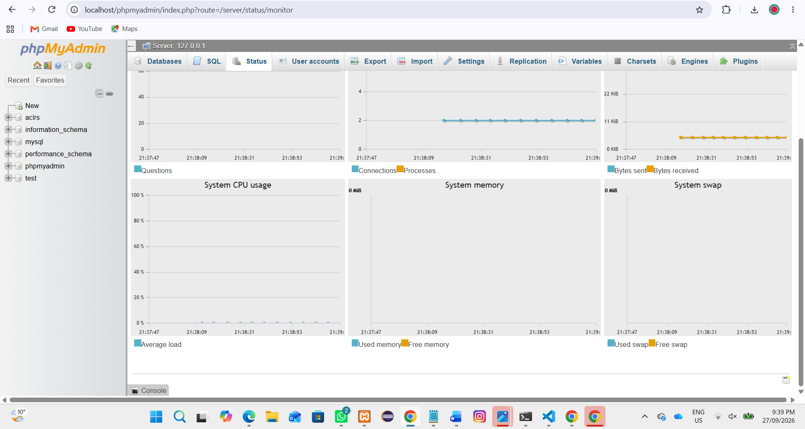
Figure 3.8.4.6 - phpMyAdmin system and database resource monitor
Evaluation Result
The database performance evaluation was completed successfully. The ACLRS database remained available and processed the observed queries and connections without a visible blocked query, aborted connection or major resource issue. Therefore, the database performance was acceptable for the current local XAMPP development and testing environment.
Limitation
This evaluation used one local computer and a small amount of demonstration data. It does not confirm performance under real laboratory conditions with many users, devices and large patient records. Additional load, stress and long-duration testing should be completed before production deployment.

